EXP 8
Aim
To resize an image to bigger and smaller sizes.
Procedure
- Import OpenCV.
- Read the image.
- Resize the image to smaller and larger sizes.
- Display all images.
- Close the windows.
Code
import cv2
img = cv2.imread("image1.png")
small = cv2.resize(img, None, fx=0.5, fy=0.5)
big = cv2.resize(img, None, fx=2, fy=2)
cv2.imshow("Original", img)
cv2.imshow("Smaller", small)
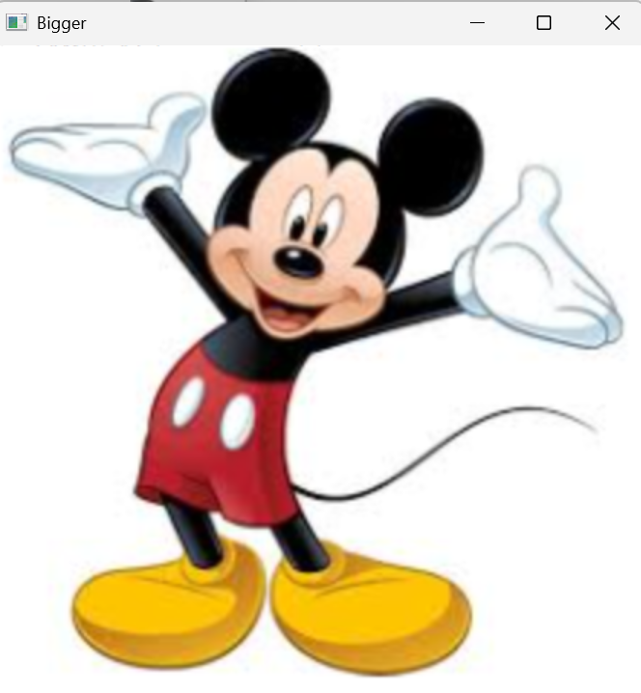
cv2.imshow("Bigger", big
cv2.waitKey(0)
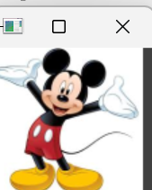
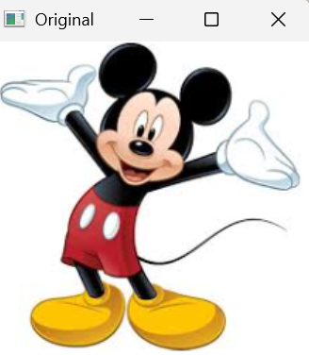
cv2.destroyAllWindows()

